**Lab 1: Introduction to DBs, SQL, Management Studio**

**1. Set up SQL Management Studio with all the databases needed in this course (i.e AP, Examples, and ProductOrders) and view all the databases that are available from the server. (All creation scripts of databases can be downloaded from Blackboard under Lab 1 directory.)**

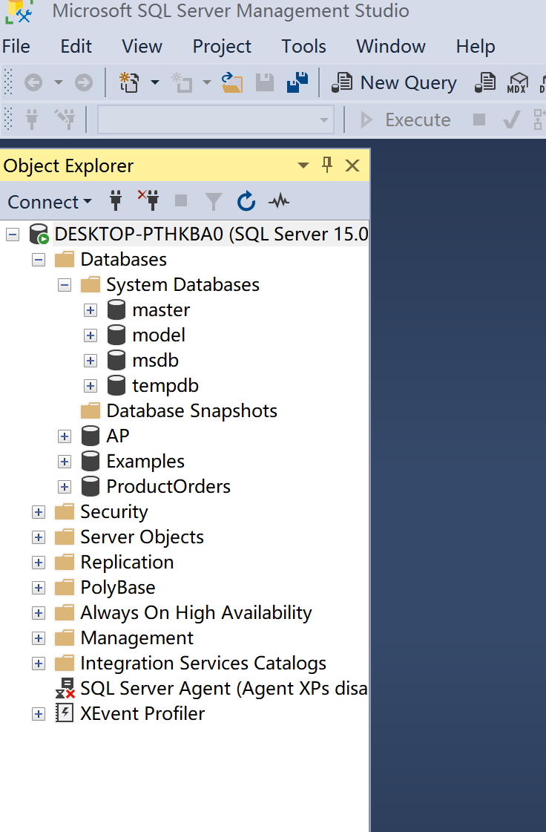The screenshot is as follow:

**2. View the tables that are available from the AP database and columns that are available in Invoices table of AP database.**

**The screenshots are as follows:**

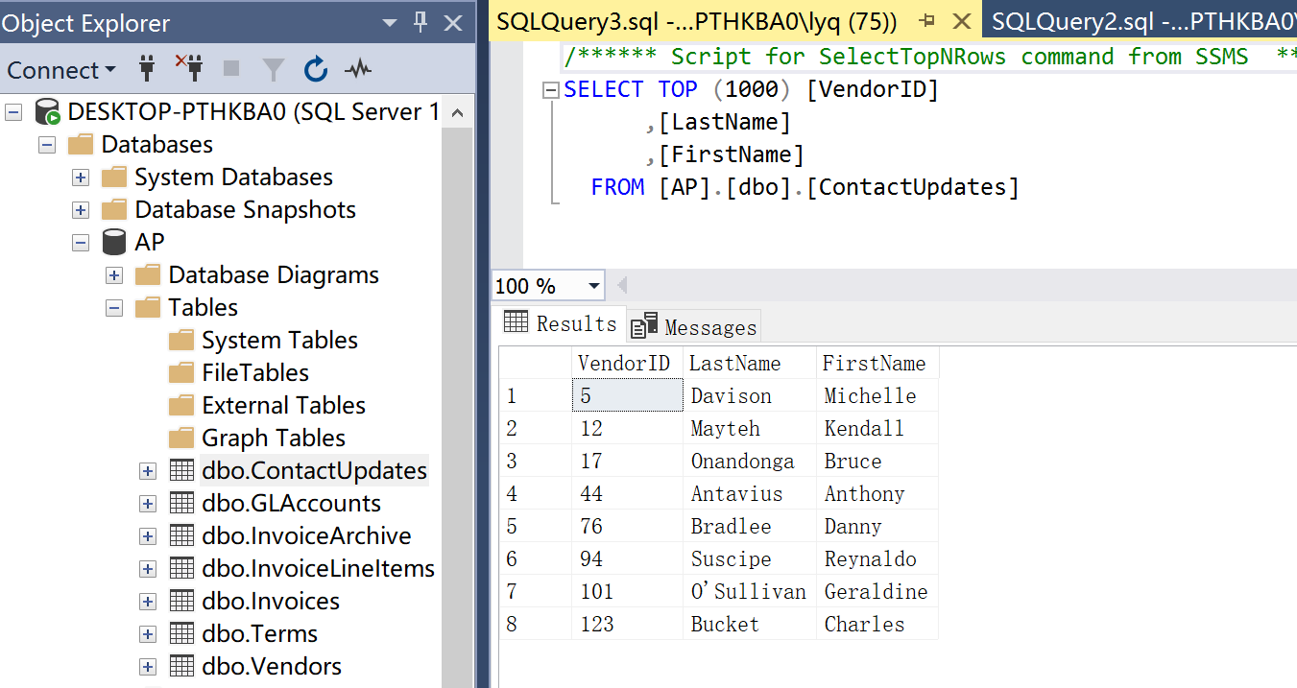2.1 Table of Contacts:

2.2 Table of GLAccounts:

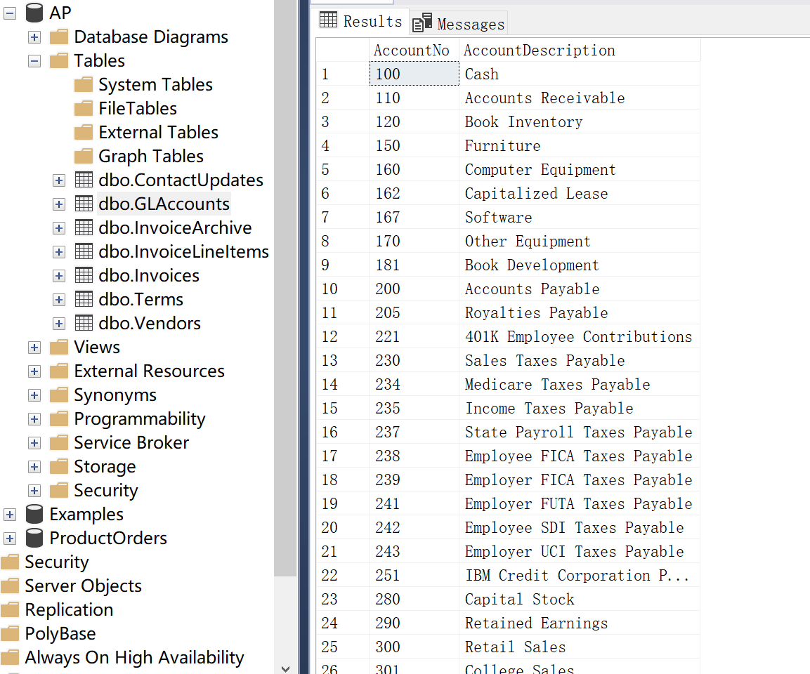

2.3 Table of InvoiceLineItems:

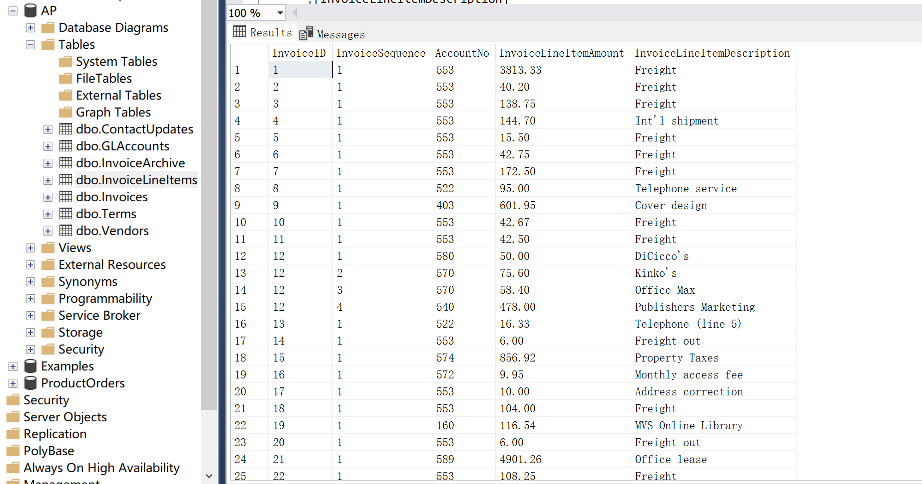

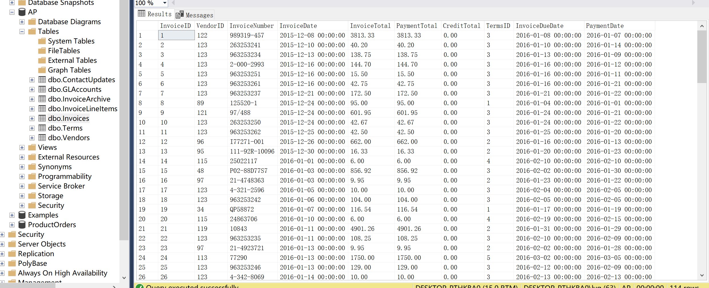2.4 Table of Invoices:

2.5 Table of Terms:

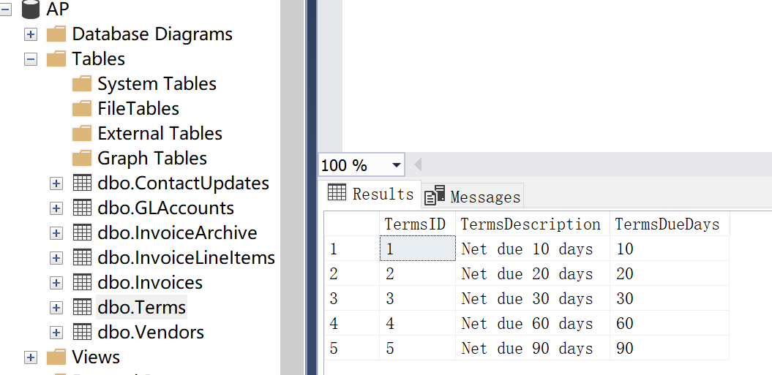

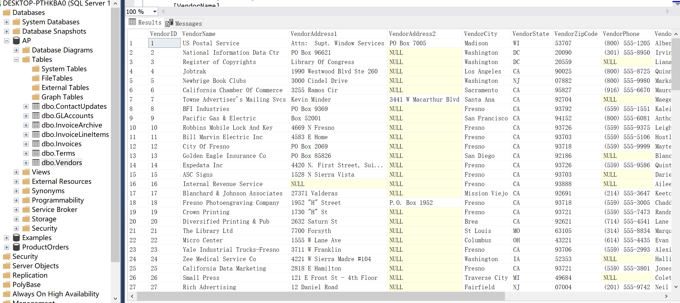2.6 Table of Vendors:

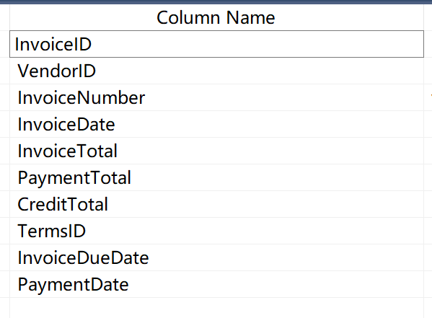2.7 Columns that are available in Invoices table of AP database:

There are 10 columns in this table.

**3. Right-click on the “Invoices” table in AP database and select “Design” command to display the “Invoices” table in a Table Designer tab. Review the properties for each column in this table and what is the Data type of “PaymentDate”? What is the identity column of “Vendors” table?**

As we could see in those two screenshot, here are the column properities and the Data type of “Paymentdate” is smalldatetime. The identity column of “Vendors” table is “VendorID”.

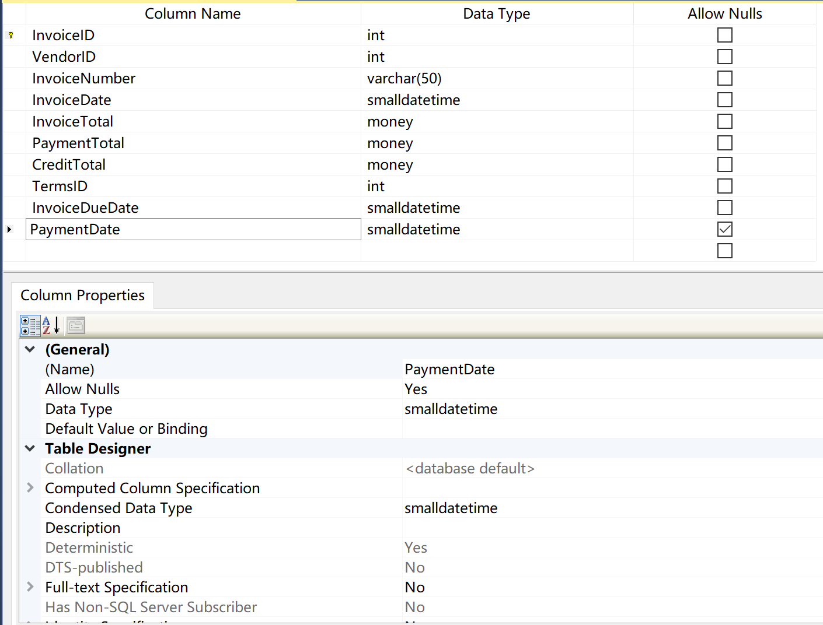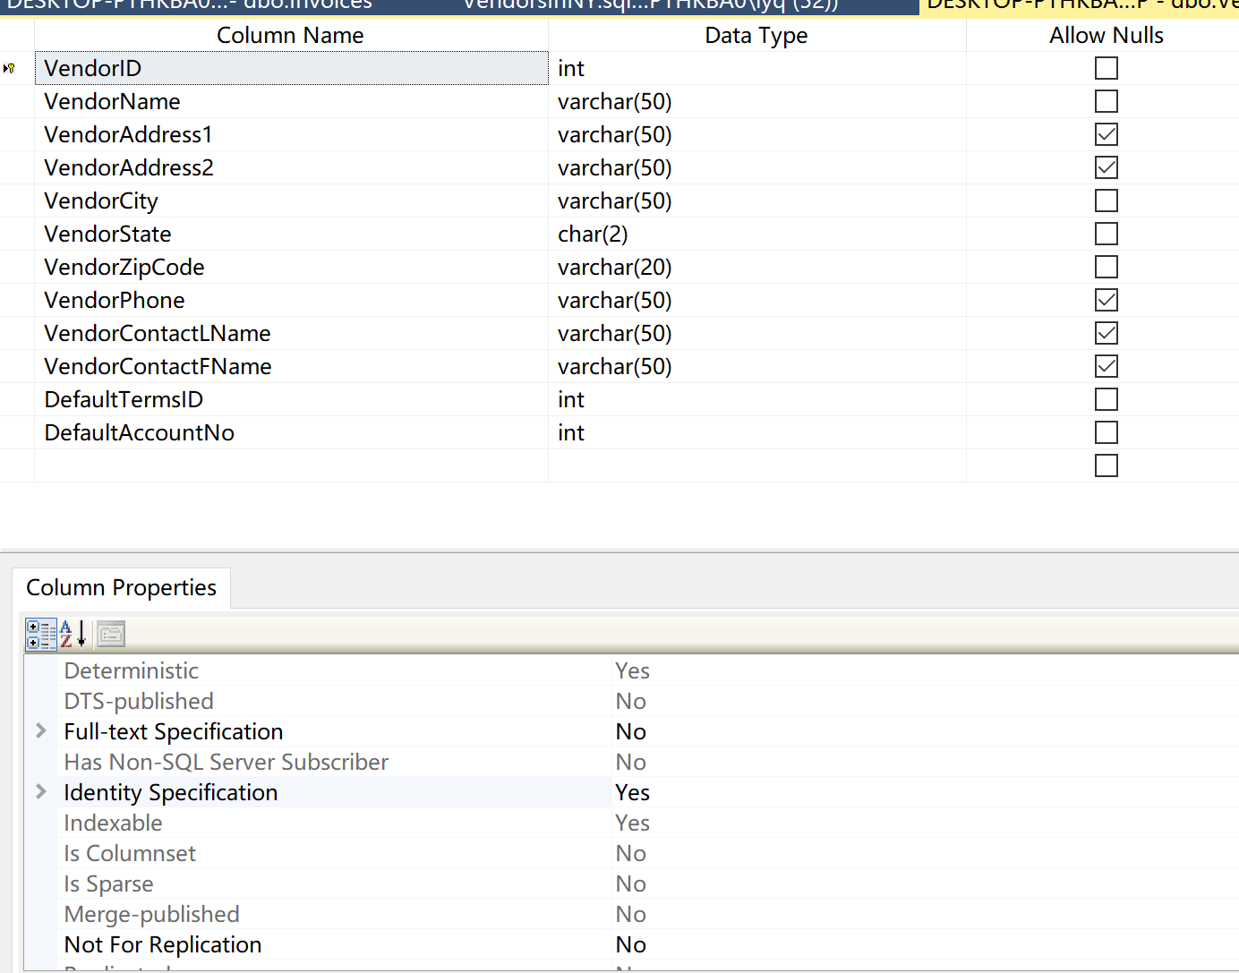

Data type of “Paymentdate”. “VendorID” is the identity column

**4. Open a new Query Editor window and then enter this SELECT statement: SELECT * FROM AP.dbo.Vendors WHERE VendorState = 'NY';**

**Press F5 to execute the query and display the results. Then, save the query with a name of “VendorsInNY” and close it.**

I have attcached the query file in the lab.

**5. Open the query named “VendorsInNY” that you saved previously in Problem 4. Then, click the Execute Query toolbar button to execute it and show the results.**

The result’s screenshot is as follow:

